Week 6 Hands on

Code:

import React from 'react';

function App() {

return (

<div>

<h1>Welcome to the first session of React</h1>

</div>

);

}

export default App;

output:

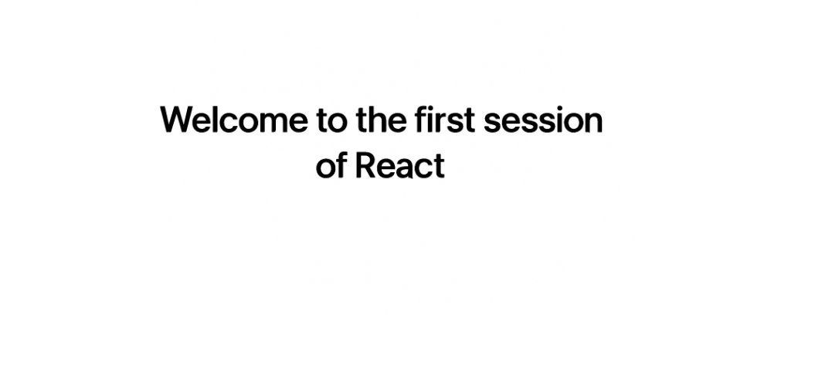

2. code

**Home.js**

import React from 'react';

function Home() {

return (

<div>

<h1>Welcome to the Home page of Student Management Portal</h1>

</div>

);

}

export default Home;

**About.js**

import React from 'react';

function About() {

return (

<div>

<h1>Welcome to the About page of Student Management Portal</h1>

</div>

);

}

export default About;

**Contact.js**

import React from 'react';

function Contact() {

return (

<div>

<h1>Welcome to the Contact page of Student Management Portal</h1>

</div>

);

}

export default Contact;

**App.js**

import React from 'react';

import Home from './Components/Home';

import About from './Components/About';

import Contact from './Components/Contact';

function App() {

return (

<div>

<Home />

<About />

<Contact />

</div>

);

}

export default App;

output:

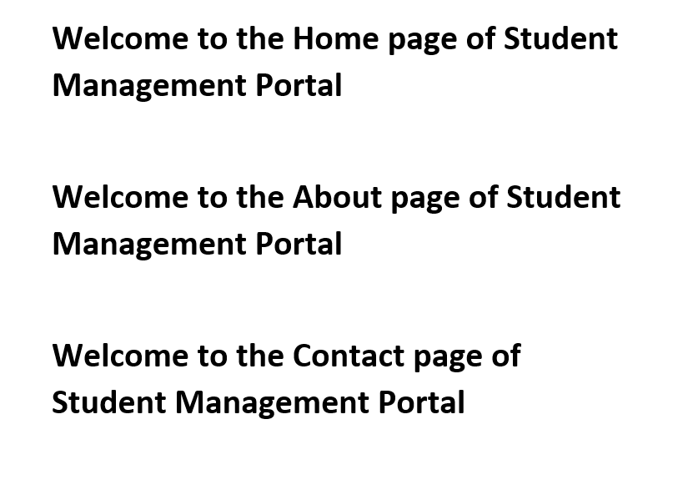

3. code

**src/Components/CalculateScore.js**

import React from 'react';

import '../Stylesheets/mystyle.css';

function CalculateScore(props) {

const average = props.total / props.goal;

return (

<div className="score-card">

<h2>Student Score Details</h2>

<p><strong>Name:</strong> {props.name}</p>

<p><strong>School:</strong> {props.school}</p>

<p><strong>Total Marks:</strong> {props.total}</p>

<p><strong>Goal:</strong> {props.goal}</p>

<p><strong>Average Score:</strong> {average}</p>

</div>

);

}

export default CalculateScore;

**src/Stylesheets/mystyle.css**

.score-card {

background-color: #f2f2f2;

border-radius: 10px;

padding: 20px;

width: 300px;

margin: 20px auto;

box-shadow: 0px 4px 8px rgba(0,0,0,0.1);

font-family: Arial, sans-serif;

}

.score-card h2 {

color: #333;

text-align: center;

}

.score-card p {

font-size: 16px;

color: #555;

}

**src/App.js**

import React from 'react';

import CalculateScore from './Components/CalculateScore';

function App() {

return (

<div>

<CalculateScore

name="John Doe"

school="Springfield High"

total={450}

goal={5}

/>

</div>

);

}

export default App;

output:

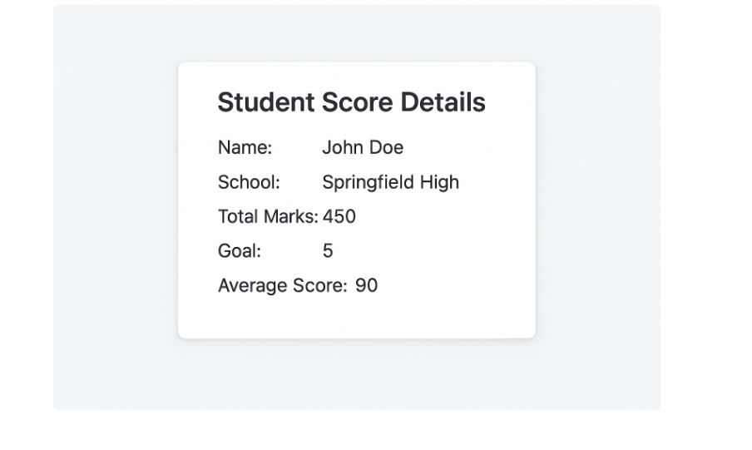

4. code

**src/Post.js**

class Post {

constructor(userId, id, title, body) {

this.userId = userId;

this.id = id;

this.title = title;

this.body = body;

}

}

export default Post;

**src/Posts.js**

import React, { Component } from 'react';

import Post from './Post';

class Posts extends Component {

constructor(props) {

super(props);

this.state = {

posts: []

};

}

loadPosts = () => {

fetch('https://jsonplaceholder.typicode.com/posts')

.then(response => response.json())

.then(data => {

const postList = data.map(

p => new Post(p.userId, p.id, p.title, p.body)

);

this.setState({ posts: postList });

})

.catch(error => {

console.error("Error fetching posts:", error);

});

};

componentDidMount() {

this.loadPosts();

}

componentDidCatch(error, info) {

alert("An error occurred: " + error);

console.error(info);

}

render() {

return (

<div>

<h1>Blog Posts</h1>

{this.state.posts.map(post => (

<div key={post.id}>

<h2>{post.title}</h2>

<p>{post.body}</p>

<hr />

</div>

))}

</div>

);

}

}

export default Posts;

**src/App.js**

import React from 'react';

import Posts from './Posts';

function App() {

return (

<div className="App">

<Posts />

</div>

);

}

export default App;

output:

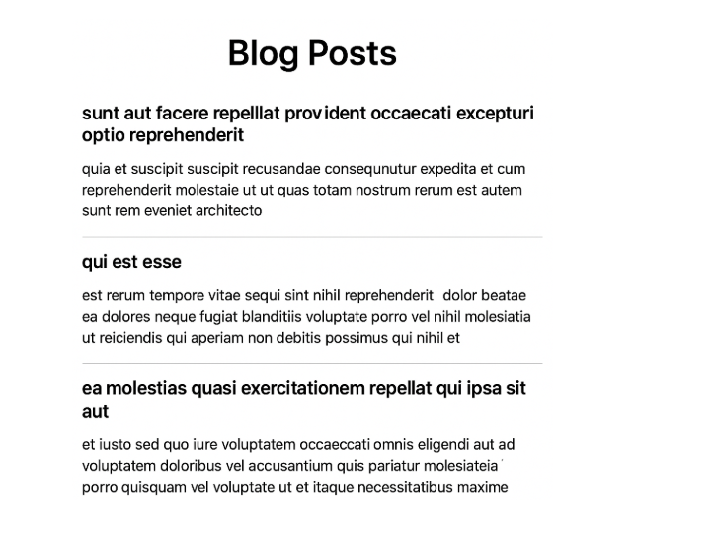

5.code

### src/CohortDetails.module.css

.box {

width: 300px;

display: inline-block;

margin: 10px;

padding: 10px 20px;

border: 1px solid black;

border-radius: 10px;

}

dt {

font-weight: 500;

}

### src/Components/CohortDetails.js

import React from 'react';

import styles from '../CohortDetails.module.css';

function CohortDetails({ name, status, startDate, endDate }) {

const headingStyle = {

color: status.toLowerCase() === 'ongoing' ? 'green' : 'blue'

};

return (

<div className={styles.box}>

<h3 style={headingStyle}>{name}</h3>

<dl>

<dt>Status:</dt>

<dd>{status}</dd>

<dt>Start Date:</dt>

<dd>{startDate}</dd>

<dt>End Date:</dt>

<dd>{endDate}</dd>

</dl>

</div>

);

}

export default CohortDetails;

### src/App.js

import React from 'react';

import CohortDetails from './Components/CohortDetails';

function App() {

return (

<div>

<CohortDetails

name="React Bootcamp"

status="Ongoing"

startDate="2025-01-10"

endDate="2025-03-10"

/>

<CohortDetails

name="Java Full Stack"

status="Completed"

startDate="2024-09-01"

endDate="2024-11-30"

/>

</div>

);

}

export default App;

output:

